

**Belagavi**

**Campus**

**Dr.M.Sheshgiri College of Engineering & Technology**

A Report on the Course Project of

**Engineering Exploration**

**(22ECRP101)**

**Title of the project**

**“AUTOMATED MEDICAL CARE”**

By

|  |  |  |
| --- | --- | --- |
| Daivik Naik | 308 | 02FE22BCS030 |
| Aisha karigar | 354 | 02FE22BCS009 |
| Chandrashekar | 306 | 02FE22BCS020 |
| Sahana H | 325 | 02FE22BCS092 |

**Under the guidance of**

**Prof. Sushant Jadhav**

**Assistant Professor**

**Dept. of E and C**

Centre for Engineering Education Research

KLE Technological University, Hubballi

Karnataka, India

Academic Year 2022-2023, Even Semester

#### CERTIFICATE

This is to certify that the course project entitled **“AUTOMATED MEDICAL CARE”** is carried out by the students Daivik Naik (308), Aisha karigar(354), Chandrashekhar(306), Sahana H (325) as part of Engineering Exploration Course (22ECRP101), during 1st Semester of B.E program for the academic year 2022-23. The project report fulfils the requirements prescribed by KLE Technological University Dr.M.S.Sheshgiri College of Engineering & Technology Belagavi,Karnataka,India

|  |  |
| --- | --- |
| __________________  Guide  Prof. Sushant Jadhav    ________________  Examiner 1: | __________________  Class Teacher  Prof . Anita Shirol  __________________  Examiner 2: |

### DECLARATION

We hereby declare that the project work entitled **“AUTOMATED MEDICAL CARE”**

submitted as a part of Engineering Exploration Course during 2nd semester of academic year 2022-2023, is a record of an original work done by us under the guidance of Prof. Sushant Jadhav .The project work and part of this report is not plagiarized to the best of our knowledge.

Date: 27/07/2023

|  |  |  |  |
| --- | --- | --- | --- |
| Your Sign | Your Sign | Your Sign | Your Sign |
| Daivik Naik | Aisha karigar | Chandrashekar | Sahana H |
| (308) | (354) | (306) | (325) |

**ACKNOWLEDGEMENT**

I would like to express my sincere thanks to **Prof Sushant Jhadav** , for his valuable guidance and support in completing my Course project.

I would like to express my gratitude toward **all my division staffs** as well as the **Prof. S B Kulkarni** for providing me a great opportunity to complete a  project on “AUTOMATED MEDICAL CARE” . Without their support and suggestions, this project would not have been completed.

I would also like to express my gratitude towards our principal **Dr. S.F Patil** for giving me this great opportunity to do a project on “AUTOMATED MEDICAL CARE”.

**Index**

|  |  |
| --- | --- |
| List of Figures | i |
| List of Tables | ii |
| Abstract | iii |
| 1. Problem Definition | 1 |
| * 1. Need Statement | 1 |
| * 1. Literature Survey | 2 |
| * 1. Questions asked to client / users for arriving at Objectives, Functions and Constraints | 3 |
| * 1. Objectives | 4 |
| * 1. Constraints | 5 |
| * 1. Functions | 6 |
| 1. Conceptual Design | 7 |
| * 1. Establishing Functions | 7 |
| * 1. Functions Tree | 7 |
| * 1. Morphological Chart | 8 |
| * 1. Generated Concepts | 9 |
| 1. Conceptual Evaluation and Product Architecture | 11 |
| * 1. Pugh Chart | 11 |
| * 1. Justification for the Scores | 12 |
| * 1. Selected Design | 13 |
| * 1. Product Architecture      1. Function Clustering | 14 |
| * + 1. Interaction between subsystems | 14 |
| 1. Implementation    1. Sprint 1 Implementation       1. 3D model of the sprint 1 | 15 |
| * + 1. Bill of Materials (BOM) of the sprint 1 | 17 |
| * + 1. Circuit diagram of the sprint 1 | 18 |
| * + 1. Flow chart of the sprint 1 | 18 |
| * + 1. Physical implementation image of the sprint 1 | 19 |
| * 1. Sprint 2 Implementation      1. 3D model of the sprint 2 | 19 |

|  |  |
| --- | --- |
| * 1. Sprint 1 Implementation      1. 3D model of the sprint 3 | 21 |
| 1. Statement of Expenditure | 22 |
| 1. Limitations of Present work and Future Scope | 23 |
| 1. References |  |

**List of Figure**

|  |  |  |
| --- | --- | --- |
| **Fig No** | **Name of the Figure** | **Page No** |
| **1.** | **Function Tree** | **6** |
| **2.** | **Morphological Chart** | **7** |
| **3.** | **Generated Concepts** | **8** |
| **4.** | **Selected Concept** | **11** |
| **5.** | **Function Clustering** | **12** |
| **6.** | **3D Model** | **14** |
| **7.** | **Circuit Diagram** | **16** |
| **8.** | **Bill of Materials** | **15** |
| **9.** | **Physical Implementation** | **17** |

**List of Table**

|  |  |  |
| --- | --- | --- |
| **Table No** | **Name of the Table** | **Page No** |
| **1.** | **Objectives, Functions and Constraints** | **1** |
| **2.** | **Objectives** | **3** |
| **3.** | **Constraints** | **4** |
| **4.** | **Functions** | **5** |
| **5.** | **Establishing Functions** | **6** |
| **6.** | **Pugh Chart** | **9** |
| **7.** | **Justification for the scores** | **10** |
| **8.** | **Interaction between Sub Systems** | **14** |

**Abstract**

We the team C-8 are here with our model “AUTOMATED MEDICAL CARE”. We have used the concept of conveyor belt for dispensing cotton. The Electrical requirements for our model are IR sensor, DC Motors, Adapter, Arduino Board, Breadboard, Glue gun and wires. The requirements to make the body of our model are Acrylic sheets, Foam sheets, Nuts and bolts . As it is a AUTOMATED MEDICAL CARE we are going to sense it and give the cotton, pills as per requirement of the user the IR sensor senses the hand which gives indications to the DC motors, with the help of the DC motor the rollers start rotating and the cotton gets dispensed. On the other hand their is pill dispening if IR senses it , pills get dispensed as per user required. This is the working process of our model.

i

**1. Problem Definition**

**1.1. Need Statement**

**Design a semiautomatic, user friendly first aid medicine dispensing kit. The machine should be of size 1.5X1.5X1.5 ft. The machine should be hygienic, and portable. The machine should be sensor based and able to accurately dispense a single medicine at a time. Moreover the machine should cost within 3000/-. The machine should be able to store three types of medicines and should be able to store a maximum of fifteen medicines. The machine should be easily accessible, it should indicate whether the machine is on or off and it must be able to sense the medicine and place accordingly.**

**1.3. Questions asked to client / users for arriving at Objectives, Functions and Constraints**

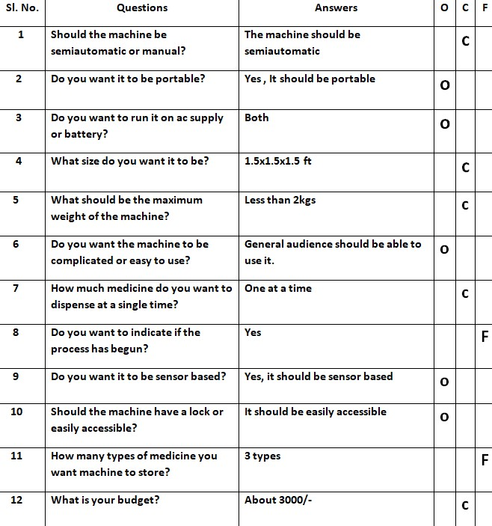

**1.4. Objectives**

|  |  |
| --- | --- |
| **Sl. No** | **Objectives** |
| **01** | **Machine should run on both ac and dc.** |
| **02** | **Machine should be portable.** |
| **03** | **Machine should be sensor based.** |
| **04** | **Machine should be easily accessible.** |
| **05** | **Machine should be User-friendly.** |

**Problem definition 1.1**

**Design a first aid medicine dispensing kit, which is sensor based and runs on both ac and dc and it should be portable and easy to use.**

**1.5. Constraints**

|  |  |
| --- | --- |
| **Sl. No** | **Constraints** |
| **01** | **Machine should be less than 2kg.** |
| **02** | **Dimensions 1.5x1.5x1.5ft** |
| **03** | **The Machine should be semiautomatic.** |
| **04** | **One medicine should be dispensed at a time.** |
| **05** | **It must be made up of non-toxic material.** |
| **06** | **Cost of the machine should be within Rs-3000** |

**Problem definition 1.2 :-**

**Design a semiautomatic, user friendly first aid medicine dispensing kit. The machine should be of size 1.5X1.5X1.5 ft. The machine should be hygienic, and portable. The machine should be sensor based and able to accurately dispense a single medicine at a time. Moreover the machine should cost within 3000/-.**

**1.6. Functions**

|  |  |
| --- | --- |
| **Sl. No** | **Functions** |
| **01** | **Indicate that process has begun to the user.** |
| **02** | **Store a maximum of fifteen medicines** |
| **03** | **The machine should keep a track of how many medicines are left** |
| **04** | **Place the medicine accordingly to predefined location.** |
| **05** | **Store three types of medicines.** |

**Problem definition 1.3:-**

**Design a semiautomatic, user friendly first aid medicine dispensing kit. The machine should be of size 1.5X1.5X1.5 ft. The machine should be hygienic, and portable. The machine should be sensor based and able to accurately dispense a single medicine at a time. Moreover the machine should cost within 3000/-. The machine should be able to store three types of medicines and should be able to store a maximum of fifteen medicines. The machine should be easily accessible, it should indicate whether the machine is on or off and it must be able to sense the medicine and place accordingly.**

**2. Conceptual Design**

**2.1. Establishing Functions**

|  |  |
| --- | --- |
| **Sl. No** | **Functions from user perspective** |
| **01** | **Automated dispensing of medical supplies** |
| **02** | **Dispensing emergency medications** |
| **03** | **Remote monitoring and management** |
| **04** | **Customization based on specific needs** |
| **05** | **Maintenance and self-check features** |
| **06** | **Multiple supply compartments** |
| **07** | **Real-time inventory tracking** |

**2.2. Functions Tree**

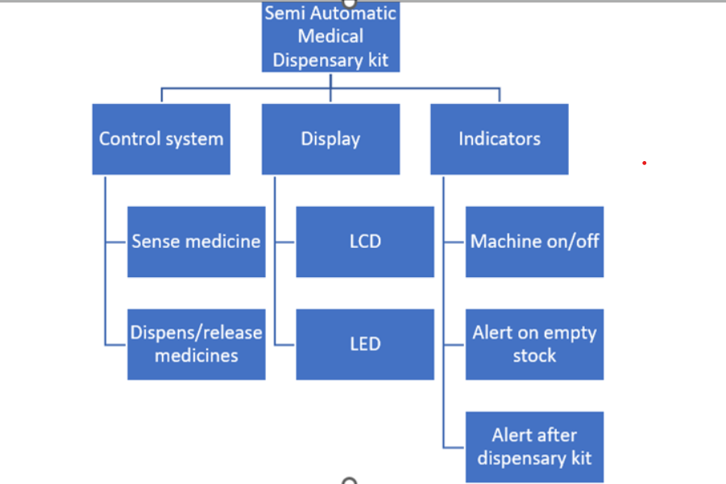

**2.3. Morphological Chart**

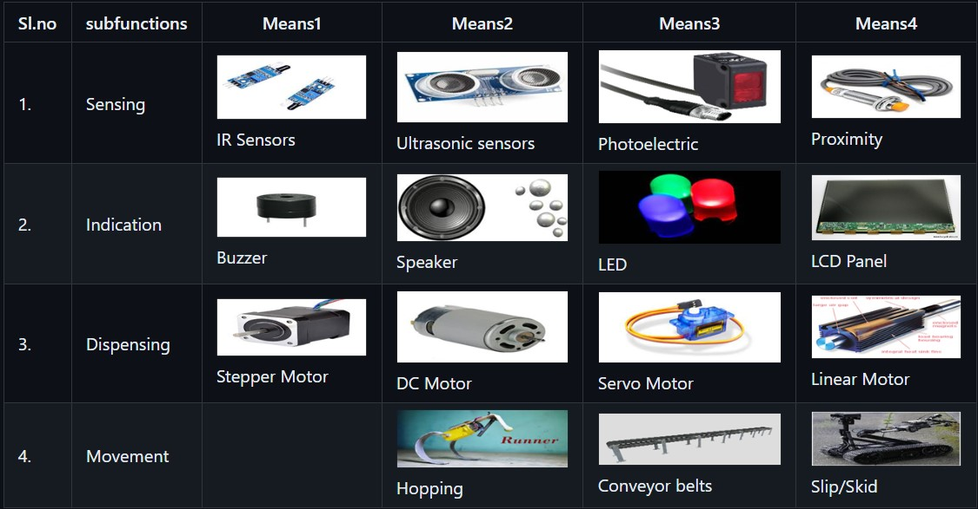

**2.4. Generated Concepts**

|  |  |
| --- | --- |
| **Concept 1** | **Concept 3** |
| **Concept 2** | **Concept 4** |

**3. Conceptual Evaluation and Product Architecture**

**3.1. Pugh Chart**

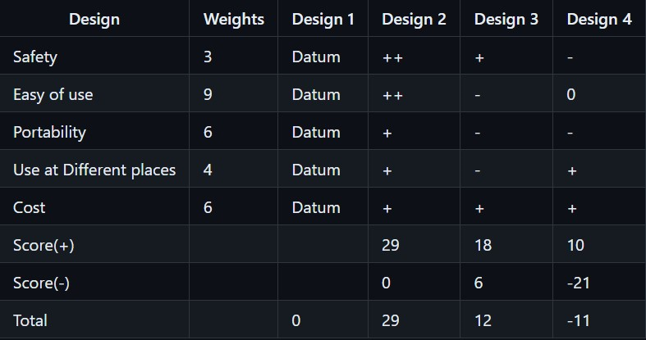

**3.2. Justification for the Scores:-**

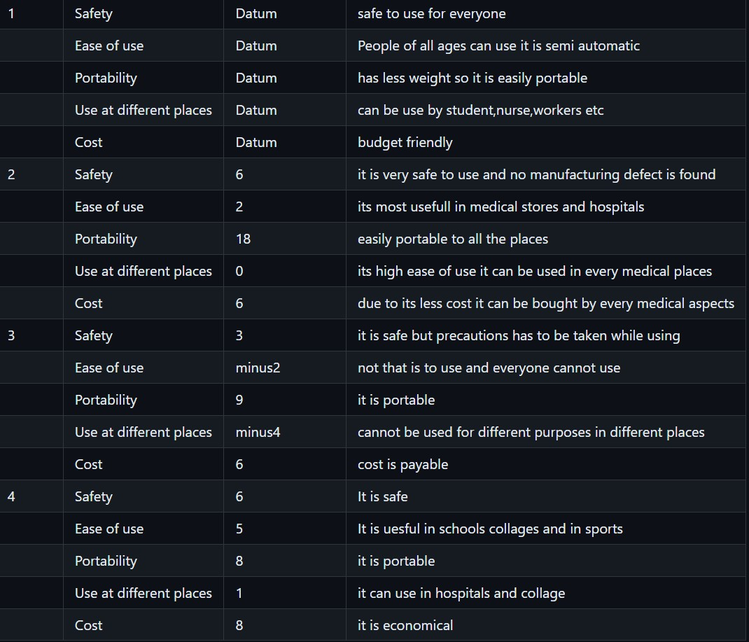

**3.3 Selected Design:-**

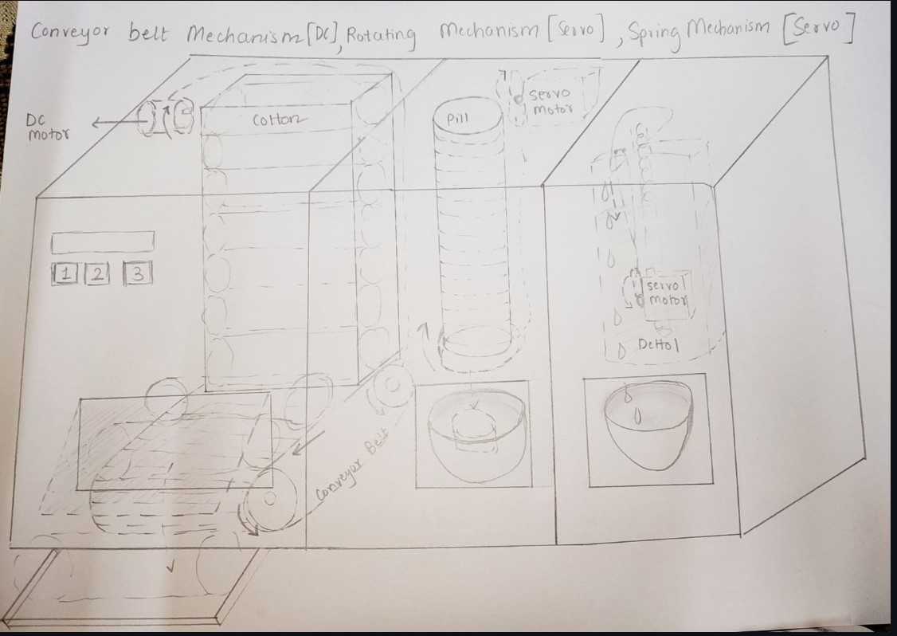

**3.4 Product Architecture**

**3.4.1 Function Clustering**

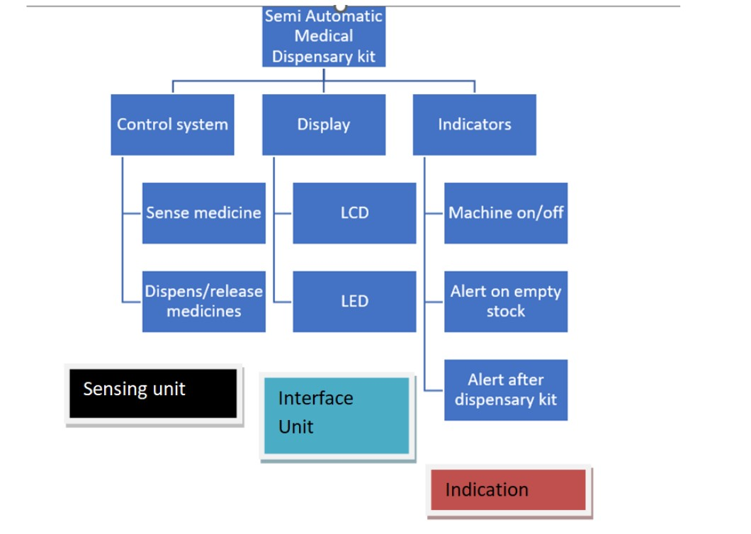

**3.4.2 Interaction between subsystems**

|  |  |  |  |  |
| --- | --- | --- | --- | --- |
|  |  | Sub System 2 | Sub System 3 | Sub System 4 |
| Sub System 1 | Material Interaction | ✓ | X | X |
| Data Interaction | X | ✓ | X |
| Spatial Interaction | X | X | ✓ |

|  |  |  |  |  |
| --- | --- | --- | --- | --- |
|  |  | Sub System 1 | Sub System 3 | Sub System 4 |
| Sub System 2 | Material Interaction | ✓ | X | X |
| Data Interaction | X | ✓ | X |
| Spatial Interaction | X | X | ✓ |

|  |  |  |  |  |
| --- | --- | --- | --- | --- |
|  |  | Sub System 1 | Sub System 2 | Sub System 4 |
| Sub System 3 | Material Interaction | ✓ | X | X |
| Data Interaction | X | ✓ | X |
| Spatial Interaction | X | X | ✓ |

**4.** **Implementation**

**4.1.** **Sprint 1 Implementation**

**4.1.1. 3D model of the sprint 1 subsystem**

|  |  |
| --- | --- |
|  |  |
|  |  |

**4.1.2. Bill of Materials (BOM) of the sprint 1**

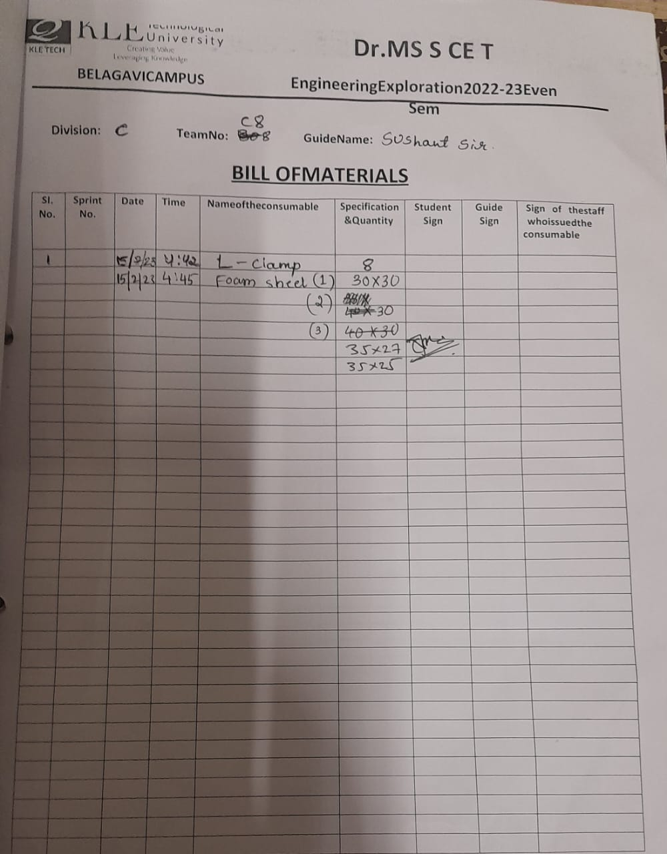

**4.2.** **Sprint 2 Implementation**

**4.2.1. 3D model of the sprint 2**

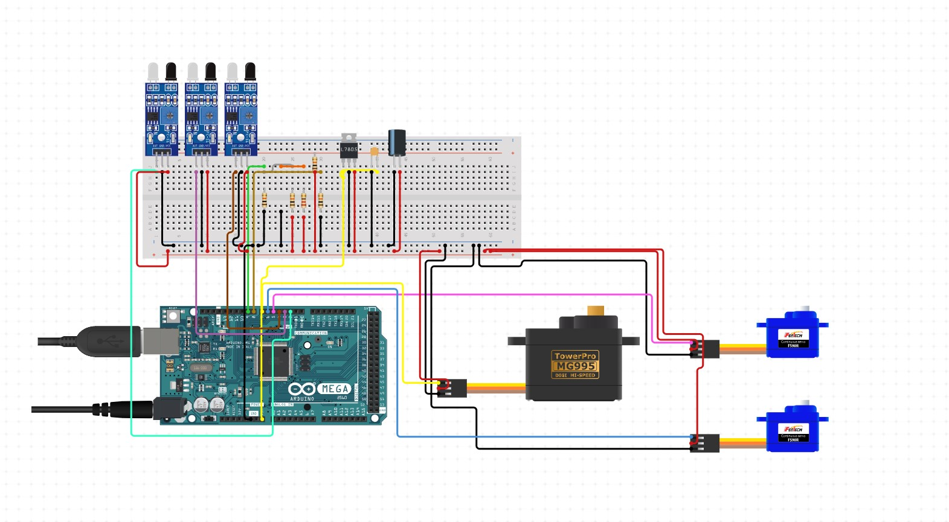

**4.3.** **Sprint 3 Implementation**

**4.3.1. 3D model of the sprint 3 subsystem**

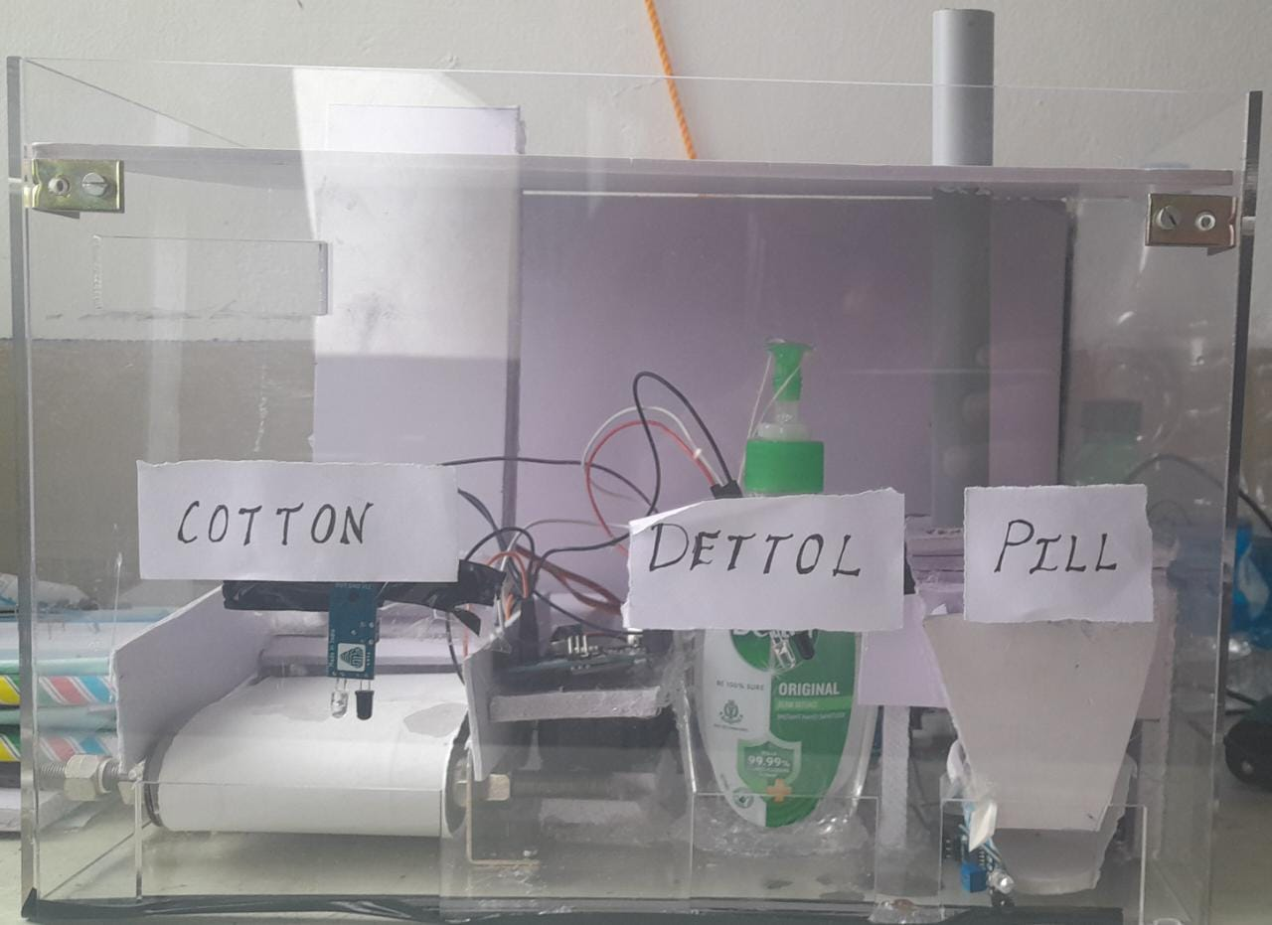

**5**. **Statement of Expenditure**

|  |  |  |  |
| --- | --- | --- | --- |
| Sl. No | Item with description | Quantity | Price in Rs. |
| 1 | Aurdino Mega 2650 board | 1 | 1400 |
| 2 | Aurdino Cable | 1 | 40 |
| 3 | Jumper Wires | 3sets | 150 |
| 4 | Adapter 12v,1A | 1 | 150 |
| 5 | IR Sensors | 3 | 120 |
| 6 | Servo Motor SG 90 | 2 | 240 |
| 7 | Servo Motor MG 996R | 1 | 450 |
| 8 | DC Motor 30rpm | 1 | 200 |
| 9 | 2 channel relay | 1 | 100 |
| 10 | Adapter jack | 1 | 20 |
| 11 | Breadboard | 1 | 65 |
| Total | | | 2785 |

Note: Include items which you have procured outside the thinkering lab.

**6. Limitations of Present work and Future Scope**

This present model is not much effective, the biggest limitation is that it cannot dispense different types of required medicines rapidly when the user needed . The model is not much stable. The durability of model is not up to the mark.

**References:**

**For dettol dispensing we have referred from:-**

<https://youtube.com/shorts/GlUzUuGvhEY?feature=share>

Article:-

https://en.wikipedia.org/wiki/First_aid_kit